Setup of a lab monitor on a raspberry pi
A short intro on why I did this project
Monitoring power
In an experimental lab with many components, this can often involve many points of failure. Furthermore, these points of failure will often be completely out of the control of the researchers, and down to technical faults and outages. One such issue is power. In the case of the project I have done for Edward Laird, this involves the cryogenic fridges.
Problem
When the power goes out momentarily and comes back online, the fridge will do the same, and the computers controlling it are connected to a UPS so they will never lose power. The problem here is that this momentary lapse in power will confuse the fridge as to what state it is in and will begin to warm the fridge up. This is an issue as this will start to evaporate the ³He inside the fridge and it will be stored in the return line. The now gaseous ³He does not return however and lingers in this pipe. The pipe can only hold about 80% of the ³He and the rest is vented to atmosphere. The total amount of ³He that the dilution fridge can hold is approximately x litres so 20% of that is about y litres. The price of gaseous ³He at atmospheric temp and pressure is approximately $2750 (Figure taken from a google search), so this can be a very expensive mishap!
Solution
What we need is a system that can detect when the power goes out and notify everyone that has access to the fridges through LUNA (software to control the fridge state) and reset the fridges as soon as possible so they may cool down again, and more importantly not vent that precious ³He to atmosphere!
Monitoring Various values and properties of the lab
Inside an experimental lab, this needs to be a controlled environment. It’s all well and good to make your experiments inside a controlled environment, but if you’re not conducting these controlled environments inside a controlled environment itself, things could go wrong very quickly! This means that it is important to monitor all these control variables in your environment to ensure that your experiment isn’t influenced in any way by the external environment
Problem
This is an experimental physics lab at Lancaster university, there is obviously going to be systems in place to check all the necessary factors for experiments such as room temp and humidity! But how can one check these values when you are not in the lab? Furthermore, a lot of the measurement instruments are completely analogue, meaning that in other words, you must be there to see it!
Solution
The solution really is quite Trivial (A favourite word of the lecturers here), we introduce digital sensors for these environmental properties and output these values to a computer. This computer can be running some software that compiles all the data into one place in a neat and tidy form factor, so it is easy to read all these values briefly.
The raspberry Pi
So, with these issues, you’re probably looking at the title and wondering where the hell a raspberry pi comes into play here? Well as I stated before, we need to compile all these values into one Computer to access and broadcast this data. So, we need a computer, and what better computer to use than a raspberry pi? It’s cheap, its powerful and it runs every scientist’s favourite language natively: Python!
Now Python is good for experimentalists due to its high-level language and extensive libraries for data analysis, making it a very powerful programming language for this specific field.
Going back to the raspberry pi, why should we use one? Well, here are the main reasons it’s beneficial to our use case here:
- Cost effective: Unlike other tiny computers, this one is very cheap, you can pick them up for about £50 quid, and that gets you a decent one! Furthermore, the Pi draws a maximum TDP of 25W, so it is incredibly cheap to run!
- Modular: Unlike more consumer computers, the raspberry pi has its 40-pin GPIO pins exposed and ready to use! This makes it very versatile as you can use different devices that plug into these pins known as Hats (Because they go on top like a hat!)
- Isolated: Unlike most machines that will come with a consumer grade OS installed such as windows, the raspberry pi comes preinstalled with PiOS, which is a skin of Debian (for the Pi 5 that I used, this would be Debian 12, which may be subject to change with hardware revisions!).

This is a skin of Linux, which is an incredibly fast, low-level and configurable OS. This means that the machine comes with almost no bloat, and it only does what you tell it to (very good for optimisation!)

This shows that the Raspberry Pi is the obvious choice for this project to maintain cost effectiveness, but we will have to get a few more components if we want to achieve what we want here!
IMPORTANT LINKS
In this section, I will leave some important links to stuff like code so it can be accessed without any fuss
- GitHub repository: https://github.com/lairdgrouplancaster/Raspberry-Pi-and-Arduino-code-for-lab-monitoring

Shopping list
Well, this is the fun bit! Here is the list of components that I used for this project. Now if you know what you are doing, a couple of these components can be swapped out for cheaper alternatives, especially the SIM hat, but I have found that the functionality of the components I have used is very good. Here is the list of parts, with links to where I got them:
Essentials
- Raspberry Pi 5 Model B Rev 1.1 https://uk.farnell.com/multicomp-pro/rpi5-starter-kit-8gb-us/raspberry-pi-starter-kit-8gb/dp/4632385. This was got off Farnell, as it was a business expense and so we could get it for cheaper, but I recommend getting one from the UK, as this came with a European plug, so I had to buy an adapter
- Waveshare Model A UPS Hat (INA219) https://thepihut.com/products/uninterruptible-power-supply-ups-hat-a-for-raspberry-pi. This allows you to directly plug the UPS hat into the pi’s GPIO pins for easy and fast monitoring
- Waveshare SIM7600E-H 4G HAT for Raspberry Pi (LTE Cat-4) https://thepihut.com/products/sim7600e-h-4g-hat-for-raspberry-pi-lte-cat-4. This was the SIM hat that was used for SMS alerts and internet access.
- 2 × 18650 Lithium-ion Rechargeable Cell - 2500mAh 3.7V 30A https://thepihut.com/products/18650-lithium-ion-rechargeable-cell-2500mah-3-7v. These are the batteries used in the UPS hat
- For the DHT11 sensor, simply get a 3 pin one with a breakout board, getting the 4 pin ones require you to have a 10kΩ pull-up resistor which also means you need a breadboard, so save yourself the time, hassle and space, get a 3 pin one! Also more importantly, get more than 1!!! The 1st one we got didn’t even work!
- A Business SIM card with LTE/PPP capability: This is so the Pi can connect to 4g networks and be able to port forward, you may have to contact your provider for details on port forwarding!
IMPORTANT NOTES
This setup can exist open top, but on the GitHub, there exists a modified .stl file for a case and corresponding lid for the raspberry pi. All links to the original creator of the case can be found in the README text section on the github under the 3D printable parts file.
If you do print the case out, a couple VERY important points!
- Assemble the pi with the hats outside the case first before you slide it in, this will make it much easier (trust me)
- When sliding the pi and hat assembly into the case, please make sure that you do this WITHOUT the SD card inside the pi!!! If you do this with it still inside the pi, you risk snapping the SD card in half (Speaking from experience!!!!)
- The case has been designed with the specific parts listed above in mind; modification of the case may be warranted if different parts are used!

The Setup Process
Initial setup
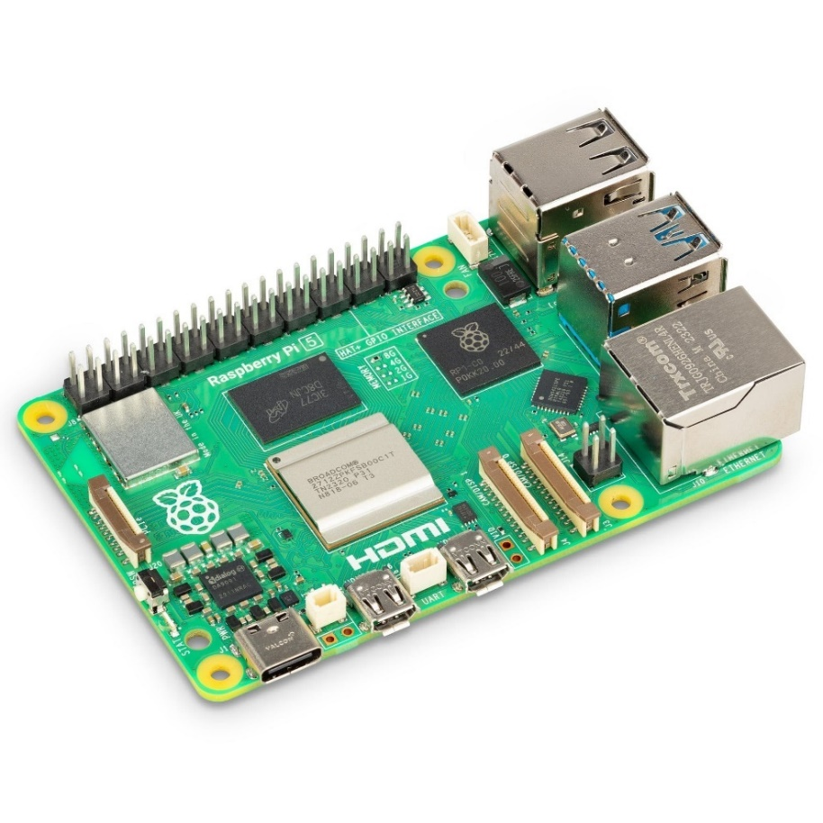
Have you got the essentials? If so, good! You’re ready to start setting up your system! If you have found a keyboard, mouse and monitor to use the raspberry pi, plug it in and power it on. The power button can be found on the side labelled here:

Once you turn the Pi on, you will see a login screen to create a User. Call your user something simple, you will need this name a lot later!

Once you have made your login credentials, you will boot into the desktop, it should look something like this:

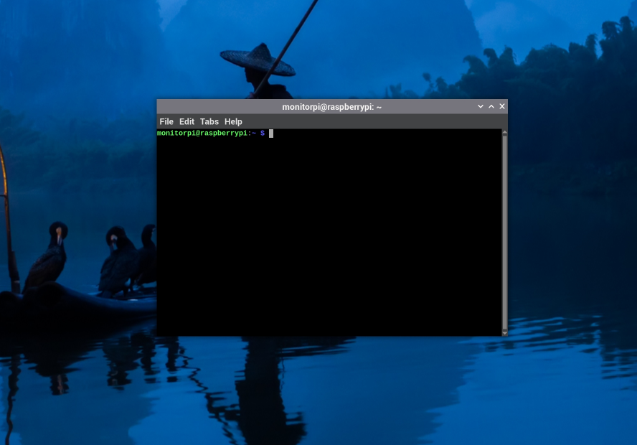
Now look in the top left at the 4 icons and click the rightmost icon. This should bring up what will come to be your best friend and worst enemy, the Linux command terminal! It will look like this:

Note the name seen here, for me, it was “monitorpi”. This is the username that you entered in at the start!
The first port of call now is to make sure that your user has administrative or “root” privileges. With the command terminal, you can run anything with root privileges anyway by adding the prefix sudo before any command you type. So, for example, if the user simply typed in:
reboot
Into the terminal, and this was prevented by the administrator, to execute the command with root privileges, you would type:
sudo reboot
and this would execute the command. This is an important point, and it is very important to make sure that your user has root privileges.
To check if your user has root privileges, type into the terminal:
getent group sudo
and hit enter. For me, I see this output:
sudo:x:27:monitorpi
we see here my username that I chose, showing that I have sudo privileges.
If your username shows up here, good! If not, simply type and run this command:
sudo usermod -aG sudo YourUsername
And run the group check again, you should then see your username in that group, if this doesn’t work, a quick internet search should solve the issue, but I didn’t run into this problem.
A quick note about this guide. I will often tell you to run command blocks! This simply means copying and pasting the paragraph of commands into the terminal and hitting enter. This will run each command line by line. This just saves you having to copy and paste line by line :)
Optional install: Upgrade Pi connect
One helpful feature of the newer pi models is pi connect, which allows you to remote into a raspberry pi that is connected to the internet from anywhere. This is how I worked on the code for the pi from home! Run these commands, hitting enter after every line, or just paste the block below and hit enter:
sudo apt update
sudo apt install --only-upgrade rpi-connect
This should mean that pi connects runs on the latest and most stable version
Setting up Home Assistant
Now that you have sudo privileges, we can now begin to set up the environment that you will be publishing all your data to! This is called Home Assistant, where the documentation can be found here: https://www.home-assistant.io/
Now to install home assistant, we need to be running on the latest python version. As of writing this, this is python 3.13.2, so this is the version we will not only be installing but running home assistant on. The reason we do this is because if we try to install home assistant on earlier versions, it works but a warning always pops up saying that that version will be depreciated, so running it on the newest python version is ideal!
For clarity, all other programs are ok to use earlier python versions, its just home assistant that is picky!
Here are the steps to install python 3.13.2 on the pi:
- Check prerequisites: Paste this command block into the terminal and hit enter to run:

sudo apt update
sudo apt upgrade -y
sudo apt install -y build-essential libssl-dev zlib1g-dev \
libncurses5-dev libncursesw5-dev libreadline-dev libsqlite3-dev \
libgdbm-dev libdb5.3-dev libbz2-dev libexpat1-dev liblzma-dev \
libffi-dev uuid-dev wget autoconf
sudo apt install python3-venv python3-pip

- Install python 3.13.2 from the source and make it an alt install: We make this newer version of python an alt install as we don’t want to overwrite our system’s native version of python (Which is the most stable version for the Pi). Paste this command block into the terminal and run:

cd /usr/src
sudo wget https://www.python.org/ftp/python/3.13.2/Python-3.13.2.tgz
sudo tar xzf Python-3.13.2.tgz
cd Python-3.13.2
sudo ./configure --enable-optimizations
sudo make -j$(nproc)
sudo make altinstall
This will take a bit of a while!

- Check python version: This should have now installed the latest version of python in a separate place! Check this by running:
python3.13 –-version

The result should say Python 3.13.2.
Great! Assuming this all works (hopefully), you should now be able to install home assistant
Here are the steps for installing Home Assistant on the pi:
- Create a dedicated Directory: This will create a dedicated directory for homeassistant that will use your new python 3.13.2 installation. Notice below the name monitorpi, just replace this with your username from earlier! Just copy the command block and run:
cd /srv
sudo mkdir homeassistant_313
sudo chown monitorpi:monitorpi homeassistant_313
cd homeassistant_313

- Setup the virtual environment and install home assistant: Virtual environments are very important, and we will use them extensively with this monitoring setup to ensure that no libraries clash by isolating them! Simply run this command block:

python3.13 -m venv .
source bin/activate
python3.13 -m pip install --upgrade pip
pip install wheel
pip install homeassistant

- Run Home assistant for the first time: Now that we have fully installed it, lets run it for the first time! Simply run the command:

hass

And this will run homeassistant for the first time, creating the necessary config files and folders

- Get home assistant to run as a background process on startup: These last few steps should now get homeassistant to be a background process that will run on startup! First of all, we will make a new directory for the service config file. Run this command below:

sudo nano /etc/systemd/system/home-assistant@monitorpi.service

This will take you into a new interface in the terminal. This is a program called nano, and it is essentially a text editor. Notice that we use the prefix sudo for this command, which allows us to write and rewrite config files. Now copy and paste the config below into this nano window exactly as it is seen below:

[Unit]
Description=Home Assistant
After=network.target

[Service]
Type=simple
User=monitorpi
ExecStart=/srv/homeassistant_313/bin/hass -c /home/monitorpi/.homeassistant
Restart=on-failure
RestartSec=10s

[Install]
WantedBy=multi-user.target

Now whilst still inside nano and you have pasted this config in, Do these 3 keyboard commands: Do Ctrl+O to bring up save options, then hit enter to save, then do Ctrl+X to quit nano and return to the regular terminal.

Now lets get it running as a background process! Copy this command block below:

sudo systemctl daemon-reexec
sudo systemctl daemon-reload
sudo systemctl enable home-assistant@monitorpi
sudo systemctl start home-assistant@monitorpi

Now let’s check that it is running! Simply run this command below:

sudo systemctl status home-assistant@monitorpi

If Home Assistant is running successfully, you should see this output:

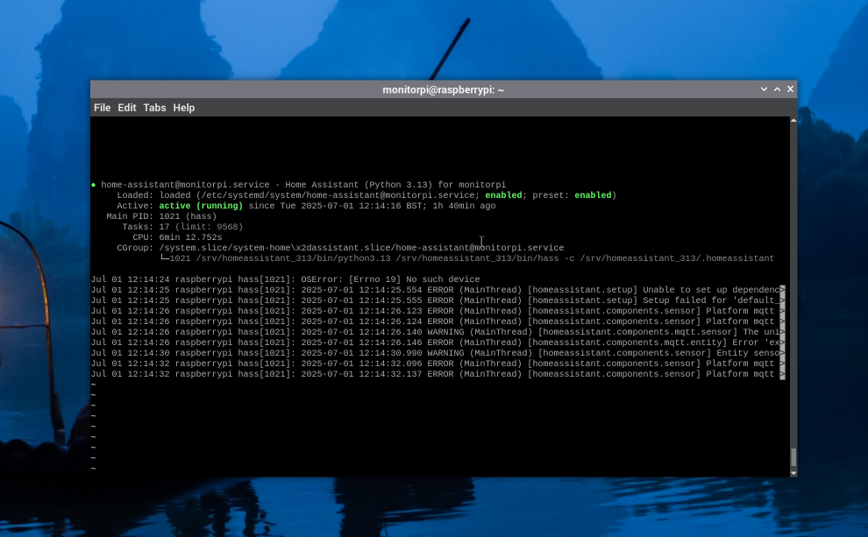
You are looking for two things seen here, the fact that it is enabled, meaning it will begin on startup, and active (running) meaning that it is currently running. If all has gone well, you should be able to access the Home Assistant instance from a browser! To access this, type into the URL bar:
http://localhost:8123
And you will be brought to the Home Assistant dashboard!
Attaching the Hats!
Now that the Pi is completely set up and running homeassistant, we need to attach the necessary hats for its operation. The method for attaching these hats can be seen below:
Setting up ModemManager
You should be starting to notice a trend here! A lot of this guide is setting up environments and telling them to run using systemctl! Lets now go through the setup of ModemManager to allow the ability to send texts and connect to the internet!
- Ensure that your SIM card is inserted into the SIM card slot of the SIM hat.
- Download all the necessary dependencies for ModemManager: Open a terminal on the raspberry pi, and copy+paste and run this command block:

sudo apt update
sudo apt install modemmanager libqmi-utils libmbim-utils -y

- Enable Serial interfaces: We now need to ensure that a couple settings on the pi are correct. Firstly, enter in the terminal:

sudo raspi-config

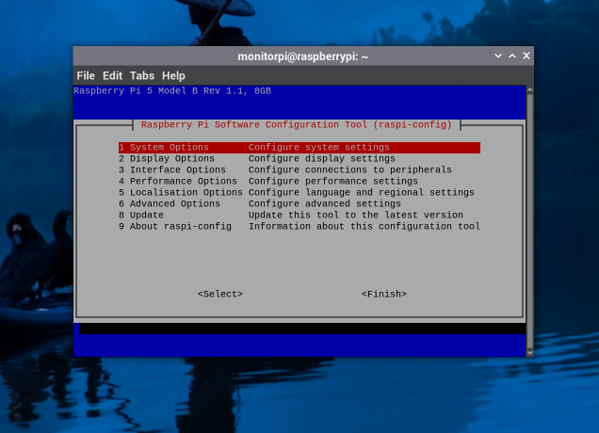
It should open a menu that looks like this:

Scroll down to Interface options using the arrow keys and hit enter.
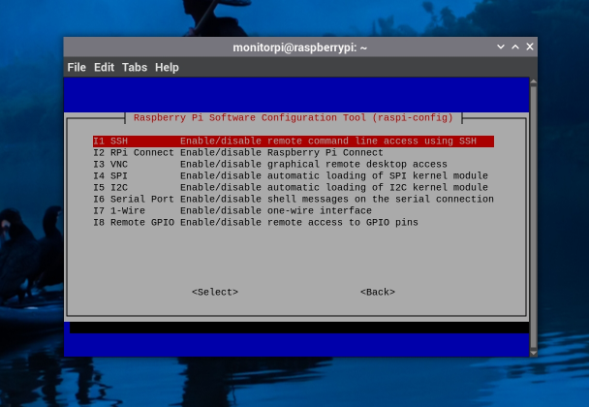
You should see this screen:

Again using the Arrow keys, scroll down to serial port and press enter. It will first ask you if you want the login shell to be accessible over serial: choose no
It will then ask you if youd like the serial port hardware to be enabled: choose yes
Now scroll down in the main menu to finish and hit enter, you will return to the terminal.
- Now reboot the pi and log back in. Lets check if our modem is being detected. Run this command:

mmcli -L

and check the output. If the modem is being detected, you should see an output like what I get when I run the command:

/org/freedesktop/ModemManager1/Modem/0 [QUALCOMM INCORPORATED] SIMCOM_SIM7600E-H

This means that your modem is being detected!

- Enable ModemManager and set up autoconnection: First of all, we need to enable modemmanager to start up on boot. We can do this by running the command:

sudo systemctl enable --now ModemManager

Once this is done, we need to get network manager to enable autoconnect.

First of all, run this command:

nmcli device

This should display a small table of devices, their type, their state and their connection. Look for the SIM hat, which will either be called cdc-wdm0 or ttyUSB2. For this device, look for its name under connection. Mine is SIM7600-4G. Remember this name!

Once you have this name, run this command:

sudo nmcli connection add type gsm ifname "*" con-name "SIM7600-4G" apn your_apn_here

Notice your_apn_here name. This is dependent on your SIM card. For mine, it was “everywhere” which is the EE apn. This is different for every provider, so check this!

Now enable the connection by running this line:

sudo nmcli connection up SIM7600-4G

You should notice your connection to the internet on the Pi go up! Let’s test this with a couple pings. Run this command block:

ping -c 3 8.8.8.8
ping -c 3 google.com

Now check the result. If both pings are successful, you are now connected to the internet!

Furthermore, check the status by running these two commands:

nmcli connection show --active
nmcli device status

and you should now see connected for your SIM hat!

- Let’s make sure this auto connects! For me, it set this as the default anyway, but it’s worth checking! Run this command:

nmcli connection show SIM7600-4G | grep autoconnect

And look for the first line of the output, which should say:

connection.autoconnect: yes

IF IT SAYS NO, run this command:

sudo nmcli connection modify SIM7600-4G connection.autoconnect yes

and check the autoconnection status again by running the connection show command again.

Let’s also make sure network manager runs on boot, run this command block:

sudo systemctl enable NetworkManager
sudo systemctl start NetworkManager

Now reboot the pi, do this from the shutdown settings at the top left, or writing in the terminal:

sudo reboot

Your Pi should now connect to the internet using 4g as soon as it starts up!

- Add Modem Failure protection: Now to protect against if your modem fails! One thing I had to do was change one tiny thing in the .service file for ModemManager. Lets do that now. To get to the service file, simply run this command:

sudo nano /usr/lib/systemd/system/ModemManager.service

You will now be in the familiar nano GUI, and should see something similar to what I have below:
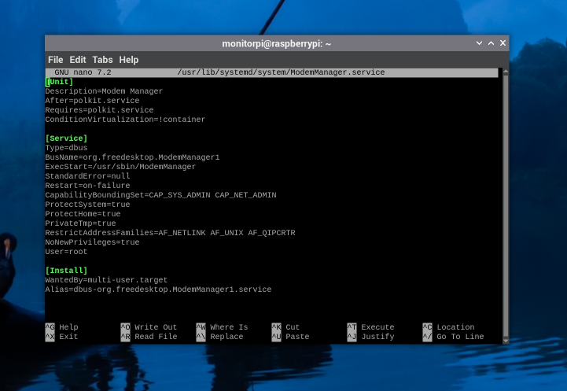

Now scroll the cursor down to restart, seen circled above, and make sure that it is set to on-failure. If not, change it and save and exit the file with the commands I stated earlier in this order: Ctrl+O, Enter, Ctrl+X.
- Add Full protection with a watchdog script: Now we are being sure! Let’s use a watchdog script that ensures that even if ModemManager encounters a catastrophic failure and cannot restart on its own, this script will do it for us! First of all, create the watchdog script by running this command

sudo nano /usr/local/bin/modem-watchdog.sh

and we will be in our familiar nano GUI. Now copy in the script from the Github repository called modem-watchdog.sh into nano and save it and exit back to terminal using the keyboard commands you should be familiar with now!

We now need to make the script executable. From the terminal, run this line:

sudo chmod +x /usr/local/bin/modem-watchdog.sh

The script will now be executable.

We now need to make a couple service files. Lets first make the service file that runs the script. Run this command:

sudo nano /etc/systemd/system/modem-watchdog.service

and paste this in:

[Unit]
Description=ModemManager Watchdog Script
Wants=network-online.target
After=network-online.target

[Service]
Type=oneshot
ExecStart=/usr/local/bin/modem-watchdog.sh

Save and exit back to terminal using the keyboard commands.

Now we need to make a timer service that runs this first service every 5 minutes. Run this command:

sudo nano /etc/systemd/system/modem-watchdog.timer

and paste this in:

[Unit]
Description=Run ModemManager Watchdog every 5 minutes

[Timer]
OnBootSec=2min
OnUnitActiveSec=5min
Persistent=true

[Install]
WantedBy=timers.target

Save and exit back to terminal again.

Now finally, enable the service and start it up by running these commands:

sudo systemctl daemon-reload
sudo systemctl enable --now modem-watchdog.timer

and check the status by running:

systemctl status modem-watchdog.timer

This should fully protect you against any failure of the modem!

Your SIM hat should now be fully set up!

Access to Home Assistant remotely
Quite easily the simplest bit of the setup! The only thing is, this costs some money to do, which is why it is so easy! For simplicity, we went with home assistant cloud, which is Home assistant’s own 1st party remote cloud service that allows you to access your instance from anywhere! The service is priced as follows:
- £6.50 for the month
- £65 a year
- 31-day free trial
The process to set this up is as follows:

Arduino IDE
We now very quickly need to install the Arduino IDE onto the pi so we can directly load C++ code onto it. If you have a preferred method of loading code onto an Arduino, use that, this is just if you don’t. The setup is actually very simple, run these 2 lines:
sudo apt update
sudo apt install Arduino -y
and wait, this install will take a bit of time. After it is done, simply run in terminal:
arduino
to open the GUI!

Power Monitoring
Ok! Let’s get into one of the most important use cases of this setup, monitoring power outages! First, let’s ensure that we have the correct integrations set up so we can publish to Home Assistant properly. We must first run some commands to install some software that allows us to publish called mosquitto. Lets get that installed first using this command block:
sudo apt update
sudo apt install mosquitto mosquitto-clients

This will install the service systemwide on the pi, which is what we want! Now we simply enable it as a systemd service:
sudo systemctl enable mosquitto
sudo systemctl start mosquitto

Which should start the service. You can always check the status of the service through:
sudo systemd status mosquitto

And check for the green enabled and running statuses. If this is not the case, try to do a fresh install of the service, and possibly try to reload the daemon with:
sudo systemd daemon-reexec
sudo systemd daemon-reload

and trying the enable start commands again.
Now that mosquitto is installed, we can set up our script! For fresh installs and no risk of conflicting libraries systemwide, we will make use of virtual environments! Hopefully right at the top we installed the necessary dependencies to create virtual environments! If not, simply run:
sudo apt install python3-venv python3-pip
To create your first virtual environment, simply type into the terminal:
python -m venv /path/to/your/script.py
When running this, it will create a virtual python environment in the path that you specified. Notice the text highlighted in red. This must be the same filepath to the publishing script! For me, my script had this filepath:
/home/monitorpi/powerpub.py
So when making my venv, I typed this:
python -m venv /home/monitorpi/powerenv
This should create the virtual environment in the correct location! We now need to activate our virtual environment. To do this, simply run this command:
source /path/to/your/venv/bin/activate
So, for me, I would type:
source /home/monitorpi/powerenv/bin/activate
You should then see in the terminal before your usual green username the name of your venv in brackets, so for me this would be (powerenv). If this is the case, great! You are now working in your virtual python environment!
Now let’s install the necessary libraries while we are inside the virtual environment. First, its good practice to make sure that pip is up to date. pip is python’s package and library installer and makes it very easy to install libraries into virtual environments. Also bear in mind that pip will only work in virtual environments and not in your systemwide environment as this has conflict risks and the pi will deny you to install more libraries without using sudo commands, so for the purpose of cleanliness with our installs, we will do everything with virtual environments . To upgrade pip, run this command whilst in the virtual environment (You’ll know you’re in the venv with the name of the venv in brackets before your username in the terminal):
pip install –upgrade pip
Which will update your package installer to its latest version! Now to install all the libraries we will need for our power monitor! Simply run:
pip install smbus2 paho-mqtt
This will install 2 libraries into our virtual environment. The smbus2 library is used for reading the I2C bus current and voltages of our UPS hat, and paho-mqtt is the library used to let python make use of our mosquitto service!
Now for the python script. The full script can be found here on github: https://github.com/lairdgrouplancaster/Raspberry-Pi-and-Arduino-code-for-lab-monitoring/blob/main/Raspberry%20Pi%20code/Python%20publishing%20scripts/UPS_Monitoring_code.py
So, create a new python file in the same place you set up your virtual environment and save the file. In the python script, you can change the minimum and maximum voltages for battery percentage and change the threshold at which the battery detects that it is discharging!
We are almost there! All we need to do is create a background service like we did for the watchdog script that starts the python script on startup and runs it as a background service! Type into the terminal:
sudo nano /etc/systemd/system/power_monitor.service
which will take you into the nano GUI. In here, paste this:
[Unit]
Description=A service that runs a python script that monitors power outages
After=network.target

[Service]
Type=simple
User=root
WorkingDirectory=/home/monitorpi
ExecStart=/home/monitorpi/powerenv/bin/python3 /home/monitorpi/powerpub.py
Restart=on-failure
RestartSec=5s

[Install]
WantedBy=multi-user.target

And save it using the keyboard commands you should be very familiar with right now!

Notice the 2 lines called ‘WorkingDirectory’ and ‘ExecStart’. On ‘WorkingDirectory’, This should be the directory of both your python venv and your script. On ‘ExecStart’, we see two filepaths. One is for activating the virtual environment, and the second is for running the script! Modify these lines with your username and filepaths if they are any different from what is seen here!

Another preference of mine is to have the ‘Restart’ line set to on-failure and the ‘User’ line set to root. This means that the service will restart itself every time it fails, and it won’t run into any permission issues as it is running as root! The ‘RestartSec’ line is simply to set a 5 second wait when restarting the service. This just allows the pi a bit of headroom and can often avoid clashing services!

Now there is one more thing we must do to get this fully working, and that is setting up the MQTT service inside Homeassistant core itself! To do this, log into your homeassistant dashboard at the link provided above when we set up homeassistant.

Once on the dashboard, click the settings cog in the bottom left corner. This will take you to the settings menu.

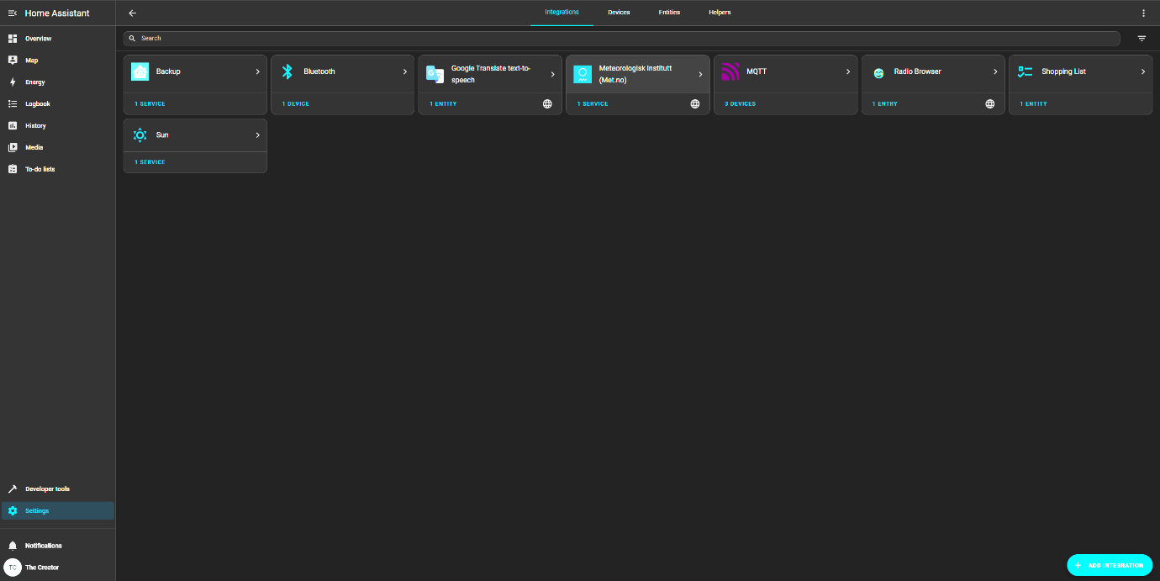
Now click the devices and services option, and this should take you to the integrations menu. It should look something like this:
This is what I currently see on my dashboard, with the purple MQTT option already being there for me as it is already set up. Lets set this up on yours too!
In the bottom right corner, there will be an option to add integration. Click this. It will then ask you to search for a brand name, type mqtt. You should then see MQTT show up.
Click this and you will be presented with a bunch of options. You want to again choose the one that is just MQTT.
You will then be presented with the configure window:
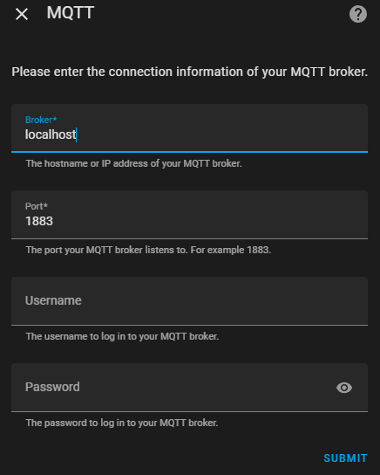

There will be 4 text boxes. You will want to leave the Username and Password boxes at the bottm blank.
The first box will be for the broker. In this, type: ‘localhost’ as seen above. There is no cause for concern about the username and password being blank, as localhost is the local network of the pi, so to hack into this, you must physically be at the pi, which is highly unlikely!
In the second box, ensure that the port is set to 1883 as seen above. This is simply the internet port that the python scripts connect to MQTT with!
Simply submit this now and MQTT should be set up not just for the power monitor service but for everything else as well!
Now the last thing, I promise! We need to set up a config file that contains all the phone numbers inside that if there ever is a power outage event, or any other event we need SMS for, all our scripts can pull the numbers from a centralised file. Let’s put this on the desktop. Simply go to the desktop and right click and choose new file.
Name the file something that you will need to remember for all the python scripts that we will be using, as if you don’t use the same name as mine, you will need to tweak the python scripts to match this.
IMPORTANT TO NOTE: Make sure that the file name has no spaces! Python often struggles with file names with spaces in, so use _ instead of space. For ease of use, the python script on the Github looks for a file called: Phone_Numbers.json so call yours that too if you don’t want to tweak the script!
Now make sure that you make the file type a .json file! This is what the python code uses to extract the numbers that we need. Inside the .json file, paste in this code from the Github: https://github.com/lairdgrouplancaster/Raspberry-Pi-and-Arduino-code-for-lab-monitoring/blob/main/Raspberry%20Pi%20code/Config%20files%20and%20scripts/phone_number_config.json
And change the numbers inside to be all the numbers you want to alert for when the power goes out! Make sure after every number in quotation marks that you put in, put a comma after it!
For easy adding and taking away of phone numbers in the file, I have written a supplementary python script that makes the process way easier! In /home/monitorpi, save this python script: https://github.com/lairdgrouplancaster/Raspberry-Pi-and-Arduino-code-for-lab-monitoring/blob/main/Raspberry%20Pi%20code/Config%20files%20and%20scripts/phone_number_edit.py
And run it in the terminal using:
python phone_number_edit.py
And this will provide an easy and user-friendly way to modify the file only with phone numbers!
Now everything should be ready to start! Simply go into the terminal and type:
sudo systemctl daemon-reexec
sudo systemctl daemon-reload
sudo systemctl enable power_monitor.service
sudo systemctl start power_monitor.service

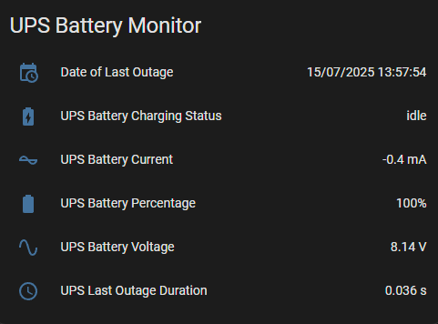
Then reboot the pi. On reboot, go to your homeassistant dashboard, and you should see this new box appear:

You will see two things updating quite quickly, the current and the voltage. This is because the script is polling these values every 0.03 seconds, which is quite fast! It is supposed to be like this though so don’t worry .
Now when the pi loses mains power, the UPS hat will switch to battery discharging, and the python script will monitor this and send out SMS alerts if the outage is at least 0.25s!

Room Temp and Humidity Monitoring
After getting the Power Monitoring stuff working, this will seem incredibly easy in comparison! This is assuming you followed the steps to connect the DHT11 to the pi at the start of this document!
First, we need to install a systemwide dependency. Simply install this by running:
sudo apt update
sudo apt install libgpiod2
and wait for these to install.
Now we will create our new virtual environment! Run this command:
python -m venv /home/monitorpi/dhtenv
and activate it:
source /home/monitorpi/dhtenv/bin/activate
Ok great! Now we need to install the necessary libraries for the DHT11 to work. Whilst in the venv, run:
pip install board lgipo paho-mqtt adafruit-blinka adafruit-circuitpython-dht
These are the necessary libraries needed for the publishing script to work. After installing these, create a new python script in the same location as the venv, and paste in the code found on the github: https://github.com/lairdgrouplancaster/Raspberry-Pi-and-Arduino-code-for-lab-monitoring/blob/main/Raspberry%20Pi%20code/Python%20publishing%20scripts/DHT_publishing_code.py
After that, save the file and run:
sudo nano /etc/systemd/system/dhtpub.service
and paste in the service file found here: https://github.com/lairdgrouplancaster/Raspberry-Pi-and-Arduino-code-for-lab-monitoring/blob/main/Raspberry%20Pi%20code/Service%20Scripts/dhtpub.service
Changing usernames and file paths as necessary.
Once that is saved, simply enable it with these four commands:
sudo systemctl daemon-reexec
sudo systemctl daemon-reload
sudo systemctl enable dhtpub.service
sudo systemctl start dhtpub.service

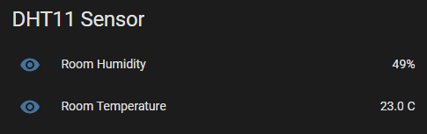
and restart the pi. When loading up the homeassistant dashboard, you should see a new box that looks like this:

That updates every couple second reading the temperature and humidity of the room!
Other sensors
In terms of the other sensors that we used for this specific project, we used a Gravity water pressure sensor: https://thepihut.com/products/gravity-analog-water-pressure-sensor
And Amphenol Ge-1337 temp sensors: https://www.mouser.co.uk/ProductDetail/Amphenol-Advanced-Sensors/GE-1337?qs=wnTfsH77Xs61T%252BHKLAasxA%3D%3D
The pressure and temperature sensors are analogue, and the flow rate sensors, like the DHT, are digital!
These sensors are controlled externally through an Arduino. An Arduino is an example of a cheap consumer-grade microcontroller that can be used for all sorts of low demand local processing; this is perfect for what we need!
This section will focus on the setup of the pressure sensor, but setup of any other sensor to the Arduino is basically identical assuming you use the corresponding scripts!
The pressure sensor linked above is an example of an analogue sensor, this matters for when we plug this into the Arduino! Let’s have a look at the plan view of the specific Arduino Uno board used in this project!
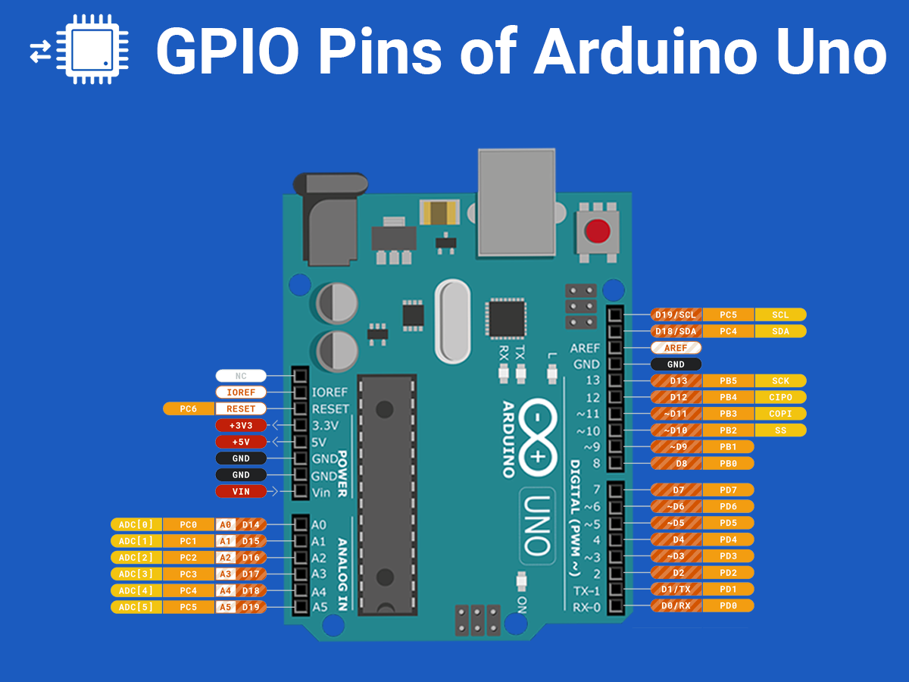
This is a conveniently labelled diagram that I found on google images. Link to the image: https://www.electronicwings.com/arduino/digital-gpio-of-arduino
Now observe the pins on the top left. These are for controlling the Arduino itself and providing power to its connected components. The connections we want to focus on are the 5V rail and the GND rail, or the ground rail! The pressure sensor works off a 5V supply from the Arduino, with all the power control being done on the Arduino itself, so it is simply plug and play.
Now notice on the bottom left. These are your analogue inputs. Since the pressure sensor is an analogue device, this is where we will need to plug in our data rail on the sensor.
On the right-hand side, we can see the digital pin outs. These will be for our digital devices, such as a water flow rate sensor used on this project, or even a device such as the DHT11 that we used earlier!
A quick note: Analogue devices provide readings through the sensors through a voltage. So, for example, a voltage range is specified by the code loaded onto the Arduino and let’s say that higher pressure gives a higher voltage. The voltage reading is then converted to a pressure reading through code loaded to the Arduino. A digital device works differently, where when connected, provides a binary output, which the code loaded to the Arduino interprets as the readings from the device. For more info on how this works, I highly recommend checking out how the DHT11 reads and outputs its readings, found here: https://www.mouser.com/datasheet/2/758/DHT11-Technical-Data-Sheet-Translated-Version-1143054.pdf
Now once you have connected the 5V, ground and data rails of the pressure sensor to the Arduino, lets plug it into the pi. Ensure you take note of which analogue or digital port you plug your device into; this is very important for the code to load onto the Arduino! Using a USB cable, connect the Arduino to the pi and type in this to the terminal:
-ls /dev/ttyACM*
This will list all the Arduinos connected to the pi through USB. If only the one is connected, you should see the output:
/dev/ttyACM0
If this doesn’t show up, the pi isn’t detecting the Arduino, but if you see this, that’s good! Now the number on the end matters, as it is needed for the python code that interprets what the Arduino hands to the pi.
To load code to the Arduino, simply open the Arduino IDE by typing the command in the terminal:
arduino
to open the GUI. With the single Arduino connected to the pi, the IDE should detect this device automatically. Now copy and paste the pressure sensor Arduino code found on the github into the IDE and first click the tick in the top left. Observe the output seen at the bottom of the screen and look for it saying that it has loaded the program to the board and how much space this takes up. This is simply a check to see if the code can be loaded properly.
Next, click the load button to the right of the verify button to load the code to the Arduino. This will load the code and start to run it.
Now we need to load the python scripts. Create a virtual environment the same way that we have done before and install the paho_mqtt and pyserial libraries. Unless specified at the top of the code, these two libraries are the only ones that need to be installed per venv.
The python code can also be found on the github per sensor that was used on the project, but the publishing logic, and especially the texting logic can be recycled and used for any sensor!
Once the python code is all set up, test the publishing by running the script, and enable the script as a background process by creating a service file like we have done before above.

